MSSE 500 - Week 7 Assignment

Name: David Freeman

Date: Oct-15-2017

I. Assignment Name: Build and/or Modify: Design Your Own Hangman game

II. Learning Objectives:

* Utilize external script files in conjunction with html and other JavaScript files and link to other HTML files.

III. Abstract -

For this week’s Hangman assignment I again chose to modify the given code. To create the five categories I made an object with five keys whose values were each an array of words. I made a dropdown and assigned a listener for a click to take the chosen value, which would be a key within the choices variable and with Math.random() choose a random word for the game. Another object will use the chosen category and it’s value will be a jpg for a matching background. Once a category is chosen the listener for the dropdown is removed, forcing the player to play the game to reload the page to get a new game.

IV. Statement of Originality

For this game I started with the provided code from GitHub and began to modify the original code in order to add allow for the player to choose a category to be given a random word from. The backgrounds are from http://www.freepik.com/free-photos-vectors/background.

1V.

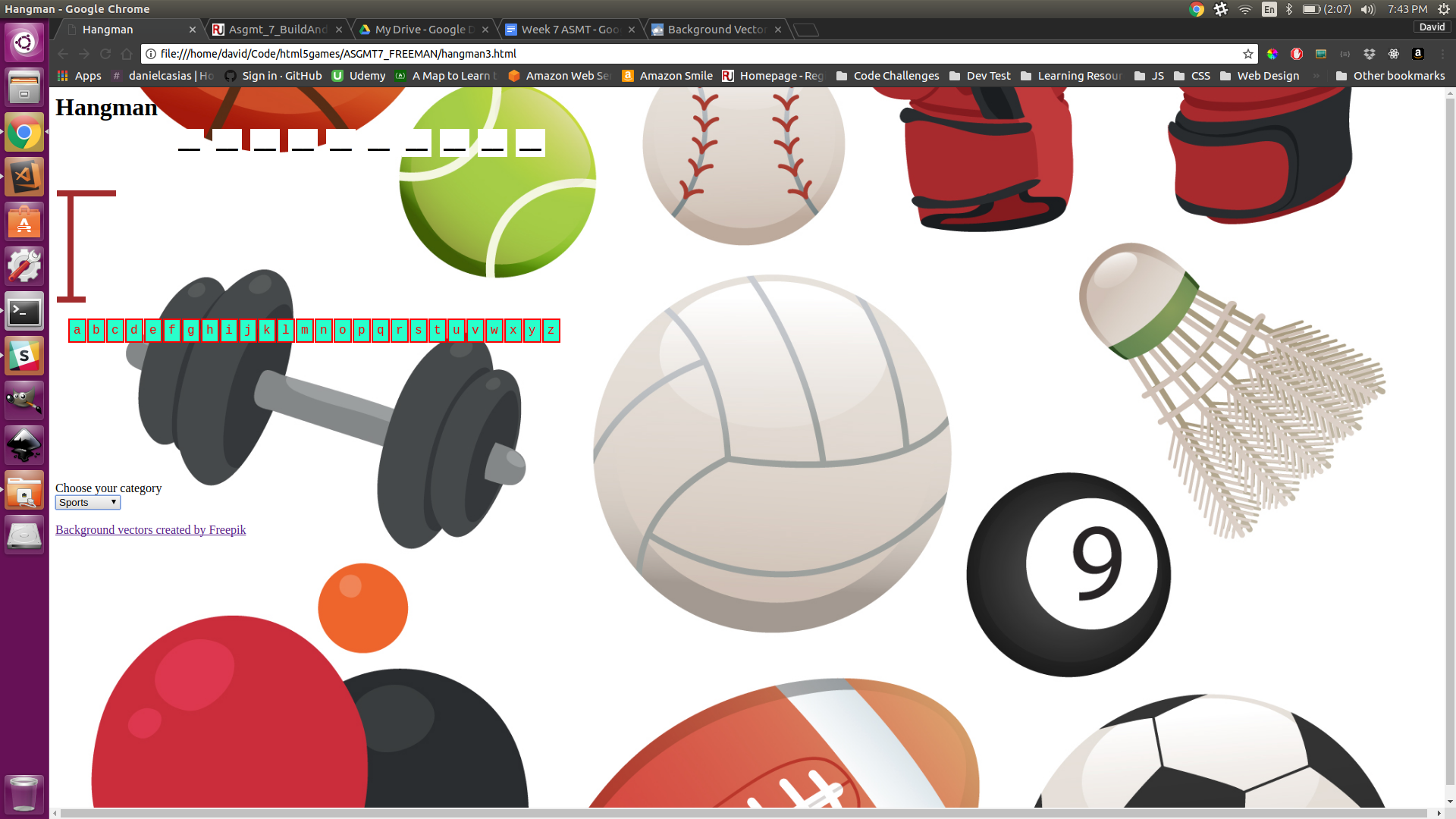

*Figure 1: Screenshot of Hangman Game*

VI.

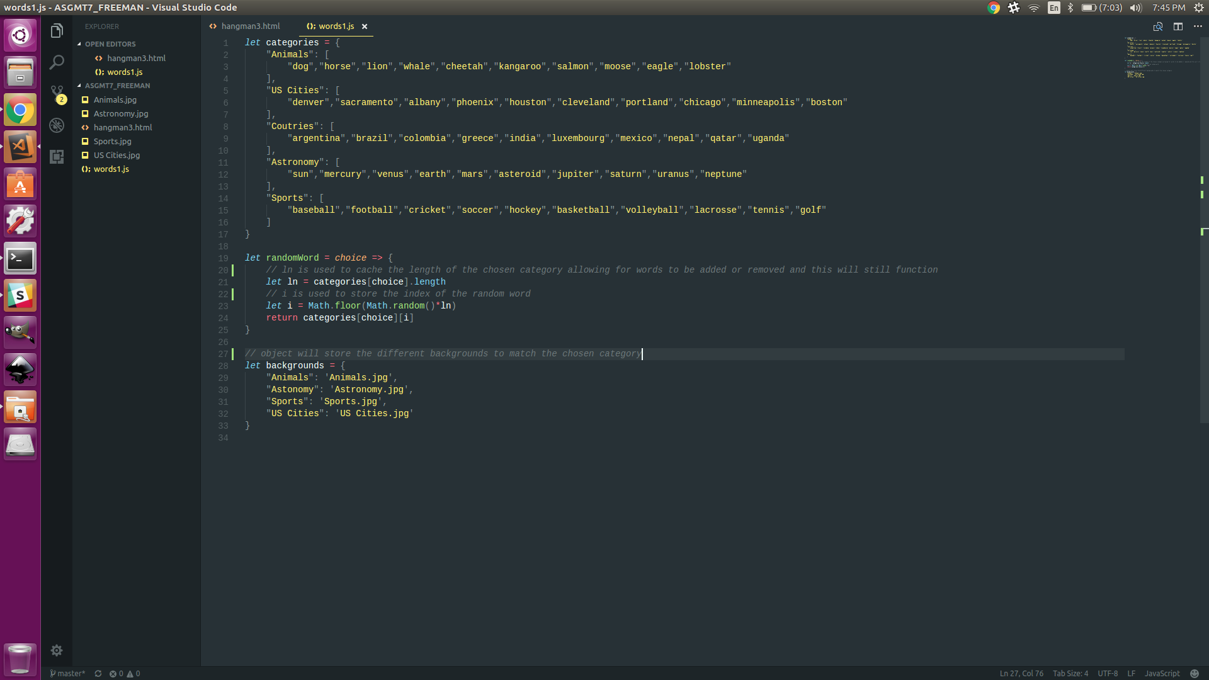

*Figure 2: Screenshot of code editor*